**convex** function = any function that has a shape like a bowl

\begin{aligned} f (tx + (1-t)y) \leq t f(x) + (1-t) f(y) \quad \text{for all } x, y \in \mathcal{X}, t \in [0, 1]. \quad -(1)\end{aligned}

Notice the equal in the “<=” sign!

From Rinaldi’s whiteboard:

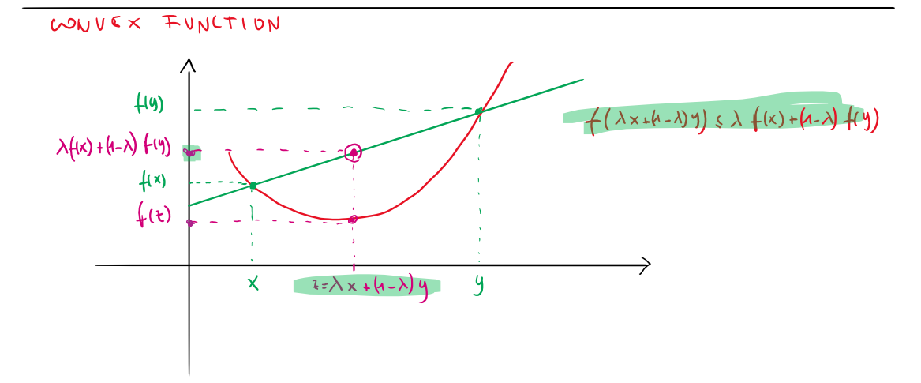

Interpretation: For any two points, we draw a line between them, and for any point on that line, the value of the function in this point is below the point on the line.

**strictly convex** function = has only one minimum (local = global)

\begin{aligned} f (tx + (1-t)y) < t f(x) + (1-t) f(y) \quad \text{for all } x \neq y \in \mathcal{X}, t \in (0, 1).\end{aligned}

Here we don’t have the equal in the sign!

Examples for strictly convex:

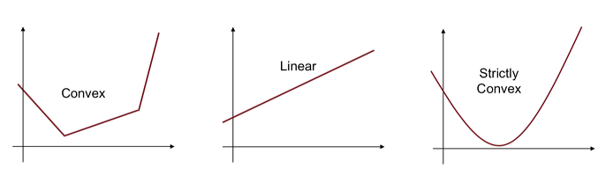

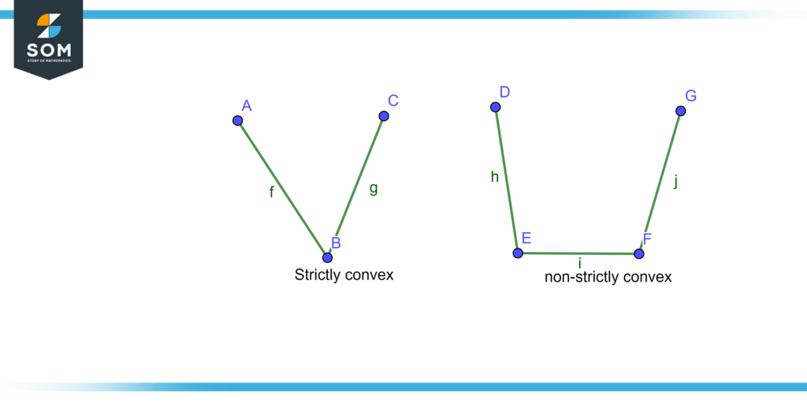

**Every strictly convex function is convex, but the reverse is not true. (see pictures above)**

**Strongly convex** function = how “convex” or “curved” a convex function is.

It can be seen as a kind of “parameterized strict convexity”.

\begin{aligned} f (tx + (1-t)y) &\leq t f(x) + (1-t) f(y) - \frac{1}{2}mt(1-t)\|x-y\|_2^2 \\ &\qquad\qquad \text{for all } x, y \in \mathcal{X}, t \in [0, 1]. \quad -(4)\end{aligned}

You can think of the parameter m as measuring how “curved” the function is: the larger m is the more curved f is. That is why f(x) = exp(x) is not strongly convex: as x goes to infinity, the curve becomes flatter and flatter (m -> 0).

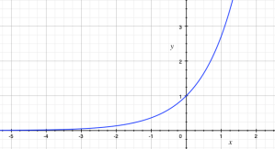

From Rinaldi’s whiteboard: (sigma is the same as m above)

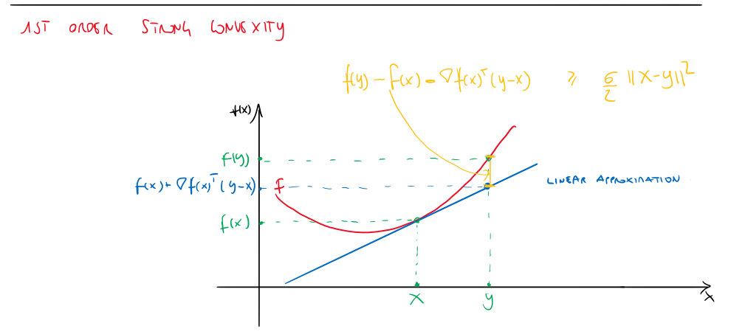

Between two strongly convex functions, the function with the larger m is more strongly convex. => this function's curvature grows more rapidly

Extras for strong convexity:

From Rinaldi’s slides (here lambda refers to t in above’s equation):

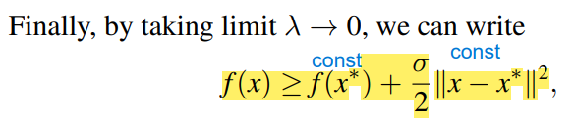

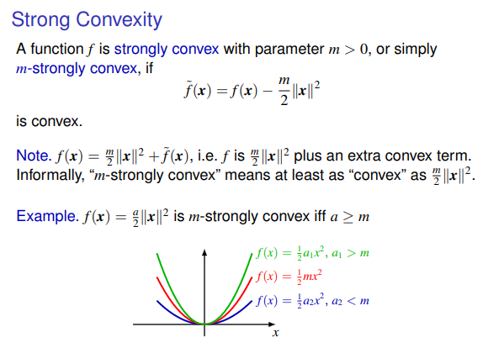

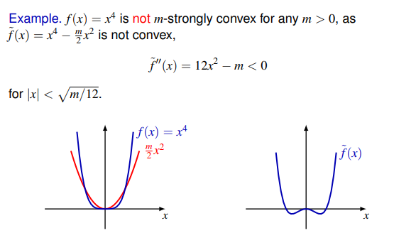

Useful link:

[(Strictly/strongly) convex functions | Statistical Odds & Ends (wordpress.com)](https://statisticaloddsandends.wordpress.com/2020/05/14/strictly-strongly-convex-functions/)